CREATE DATABASE IF NOT EXISTS sujal_db
COMMENT "Database for Asiignments"
LOCATION "/user/hive/warehouse/sujal_db.db"
WITH DBPROPERTIES ("creator"="instructor", "date"="2026");

show databases like 'sujal*';
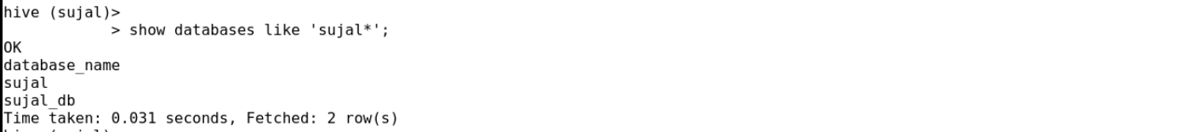

create table airport(
airport_id int,
name string,
city string,
country string,
iata string,
icao string,
latitude double,
longitude double,
altitude int,
timezone double,
dst string,
tz string)
row format delimited
fields terminated by ','
stored as textfile;
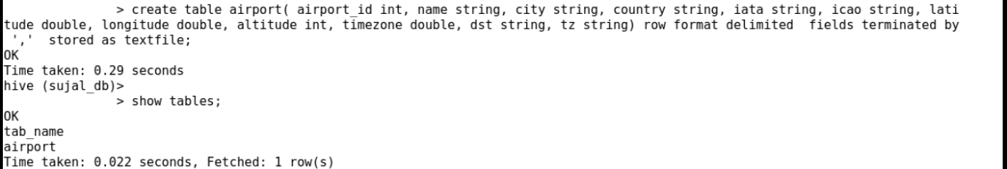

load data local inpath '/home/cddacmaylab0120/airports_mod.dat' overwrite into table airport;

select count(airport_id) from airport;
total = 8107
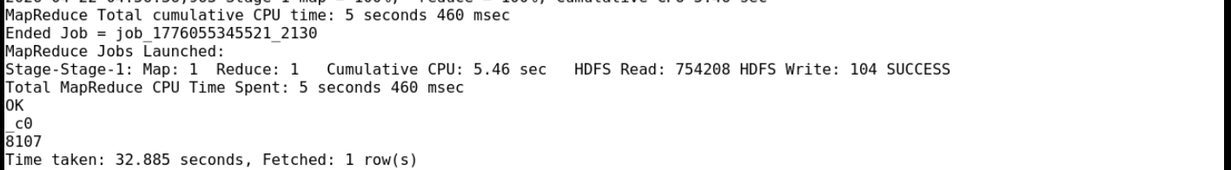

select country, count(airport_id) from airport group by country;
India = 140

create table airlines(
airline_id int,
name string,
alias string,
iata string,
icao string,
callsign string,
country string,
active string)
row format delimited
fields terminated by ','
stored as textfile;
load data local inpath '/home/cddacmaylab0120/Final_airlines' overwrite into table airlines;
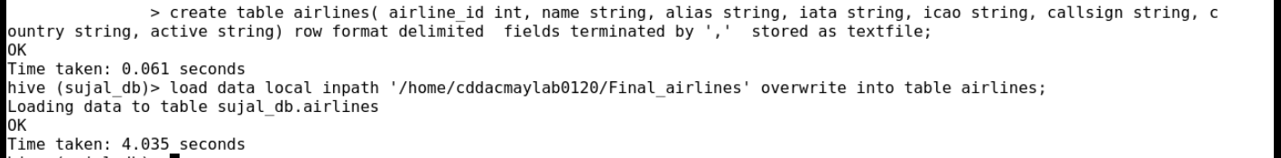

select count(airline_id) from airlines;

create table routes(
airline_iata string,
airline_id int,
src_airport_iata string,
src_airport_id int,
dest_airport_iata string,
dest_airport_id int,
codeshare string,
stops int,
equipment string)
row format delimited
fields terminated by ','
stored as textfile;

load data local inpath '/home/cddacmaylab0120/routes.dat' overwrite into table routes;

select count(*) from routes;

